**Code FUNDOO++**

Team Saviours

Motto: To save human lives from natural disasters 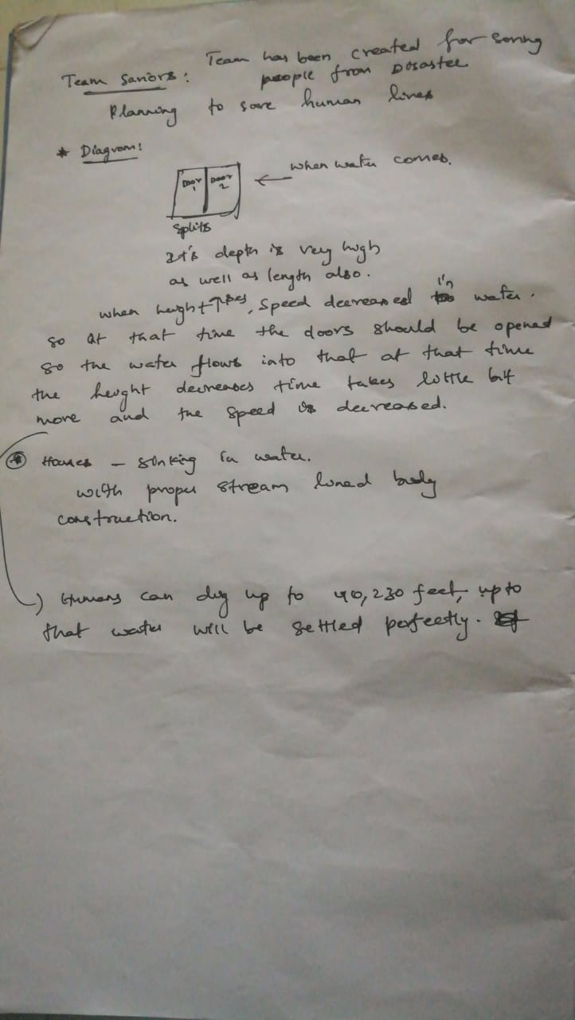 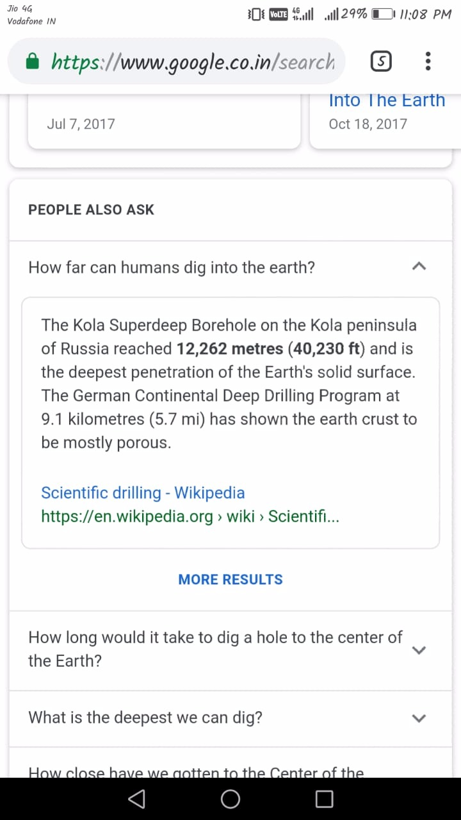

Aero dynamical Vaults In House

The houses must consist of secure vaults which is built with proper aerodynamics. These vaults must have proper adrenaline injections and oxygen cylinders for the people to survive inside it.it must be designed in such a way that it floats and come to the top of the water in case of tsunami.